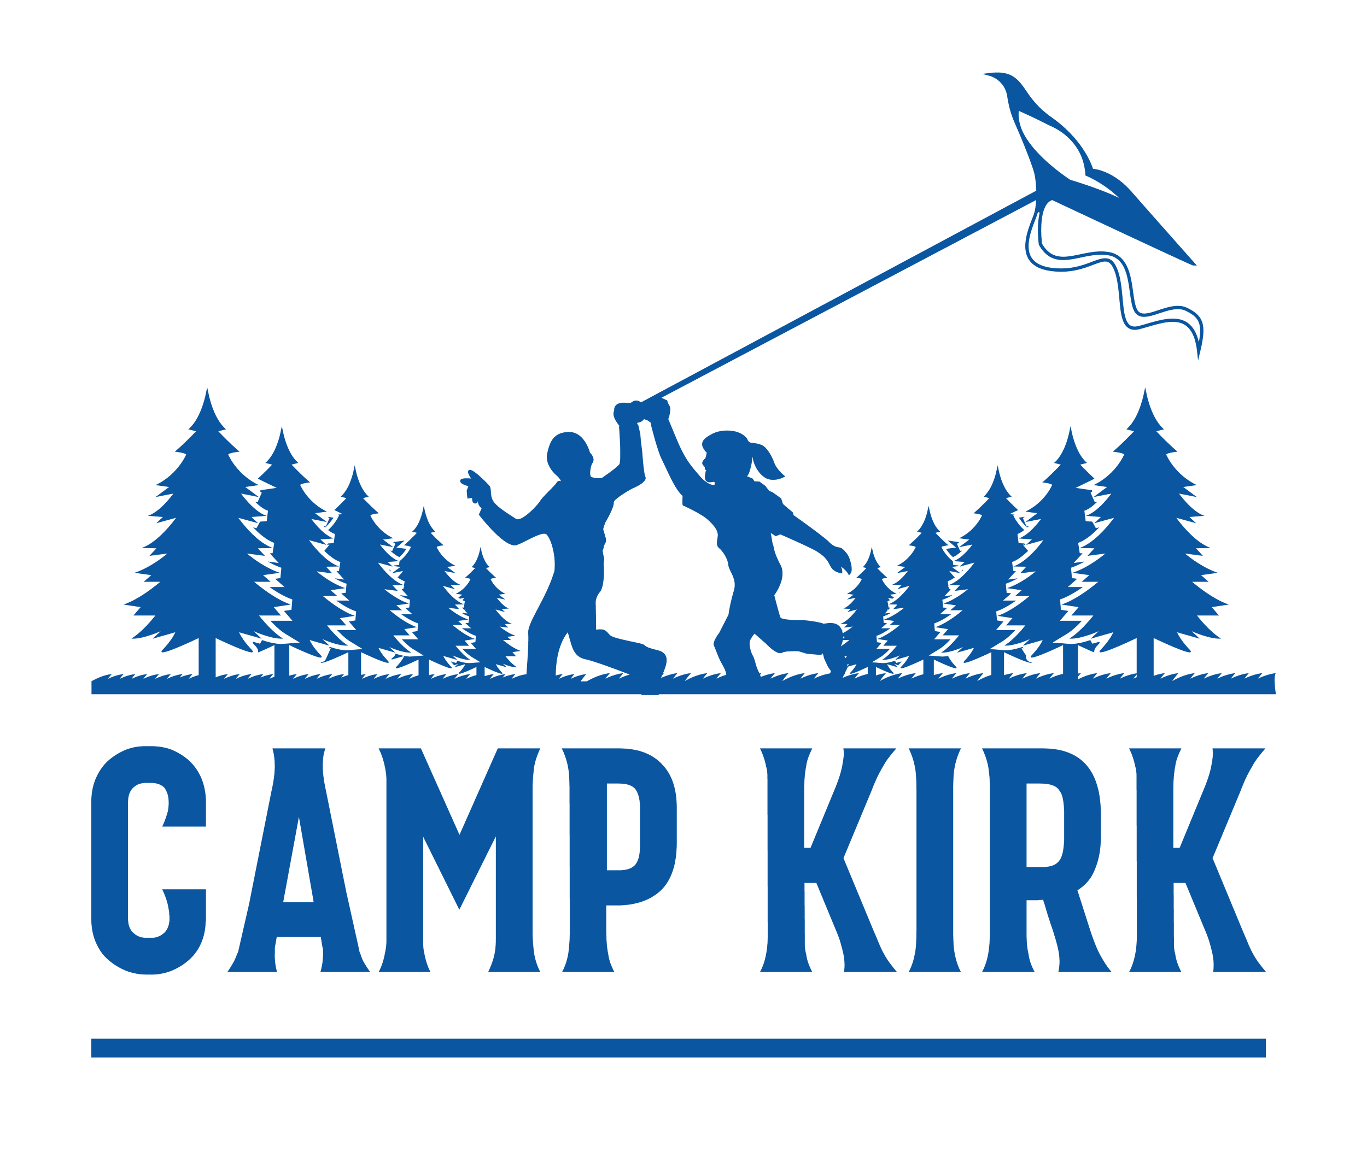

Job Posting:

Sous Chef + Baker

ORGANIZATION
Camp Kirk empowers neurodiverse kids and youth to reach their potential through
recreational programs. Within a small and nurturing community, our programs
emphasize strengths so that participants can develop confidence, connection and
community. Camp Kirk supports neurodiverse kids and youth, ages 6-17. The majority of our campers have learning disabilities, autism, and/or ADHD.

JOB DESCRIPTION
The Sous Chef will assist in all food preparation and kitchen operations. Specific duties include:
- Preparing nutritionally balanced camp meals, snacks, and out-trip food
- Completing all scratch baking (fresh breads and desserts)
- Overseeing and managing the meal service
- Cleaning and sanitizing the kitchen facilities and equipment
- Assisting in receiving food orders and inventory management
- Mentoring/training kitchen assistants

CONTRACT DETAILS
Dates of employment: June 10th - August 27th 2026
Compensation: $14,850

REQUIREMENTS
- 21+ years old by June 2026
- 3+ years experience in a similar role or kitchen environment
- Strong knowledge of cooking and scratch baking methods, commercial kitchen equipment, and food safety
- Familiar with Ontario Public Health safety and sanitation expectations in a kitchen setting
- Ability to run/manage kitchen if chef were to be absent
- Strong communication skills, positive attitude, flexible mindset, punctual
- Leadership traits and willingness to teach/instruct kitchen assistants
- Ability to adapt to changes in workplace circumstances and/or environment
- Ability to lift up to 50lbs
- Criminal Record Check or Vulnerable Sector Screening for individuals over 27 years of age
- Food Handlers Certification required by June 2026

APPLICATION
Please head to campkirk.com/jobs to submit an online application.

Equal Opportunity and Accessibility Commitment
Camp Kirk is an equal opportunity employer and is committed to fostering an inclusive and accessible workplace that celebrates diversity and values the contributions of all individuals. We welcome applicants of all abilities and provide accommodations to ensure equal access throughout the hiring process.
If you require accommodations at any stage of the application or hiring process, please contact us at kristen@campkirk.com or 416 782 3310 and we will work with you to meet your needs.
We strive to ensure our workplace is inclusive and supportive, and we actively promote an environment where all team members can thrive. For more information about our accessibility policies or to request accommodations, visit https://campkirk.com/wp-content/uploads/2021/09/AODA.pdf

