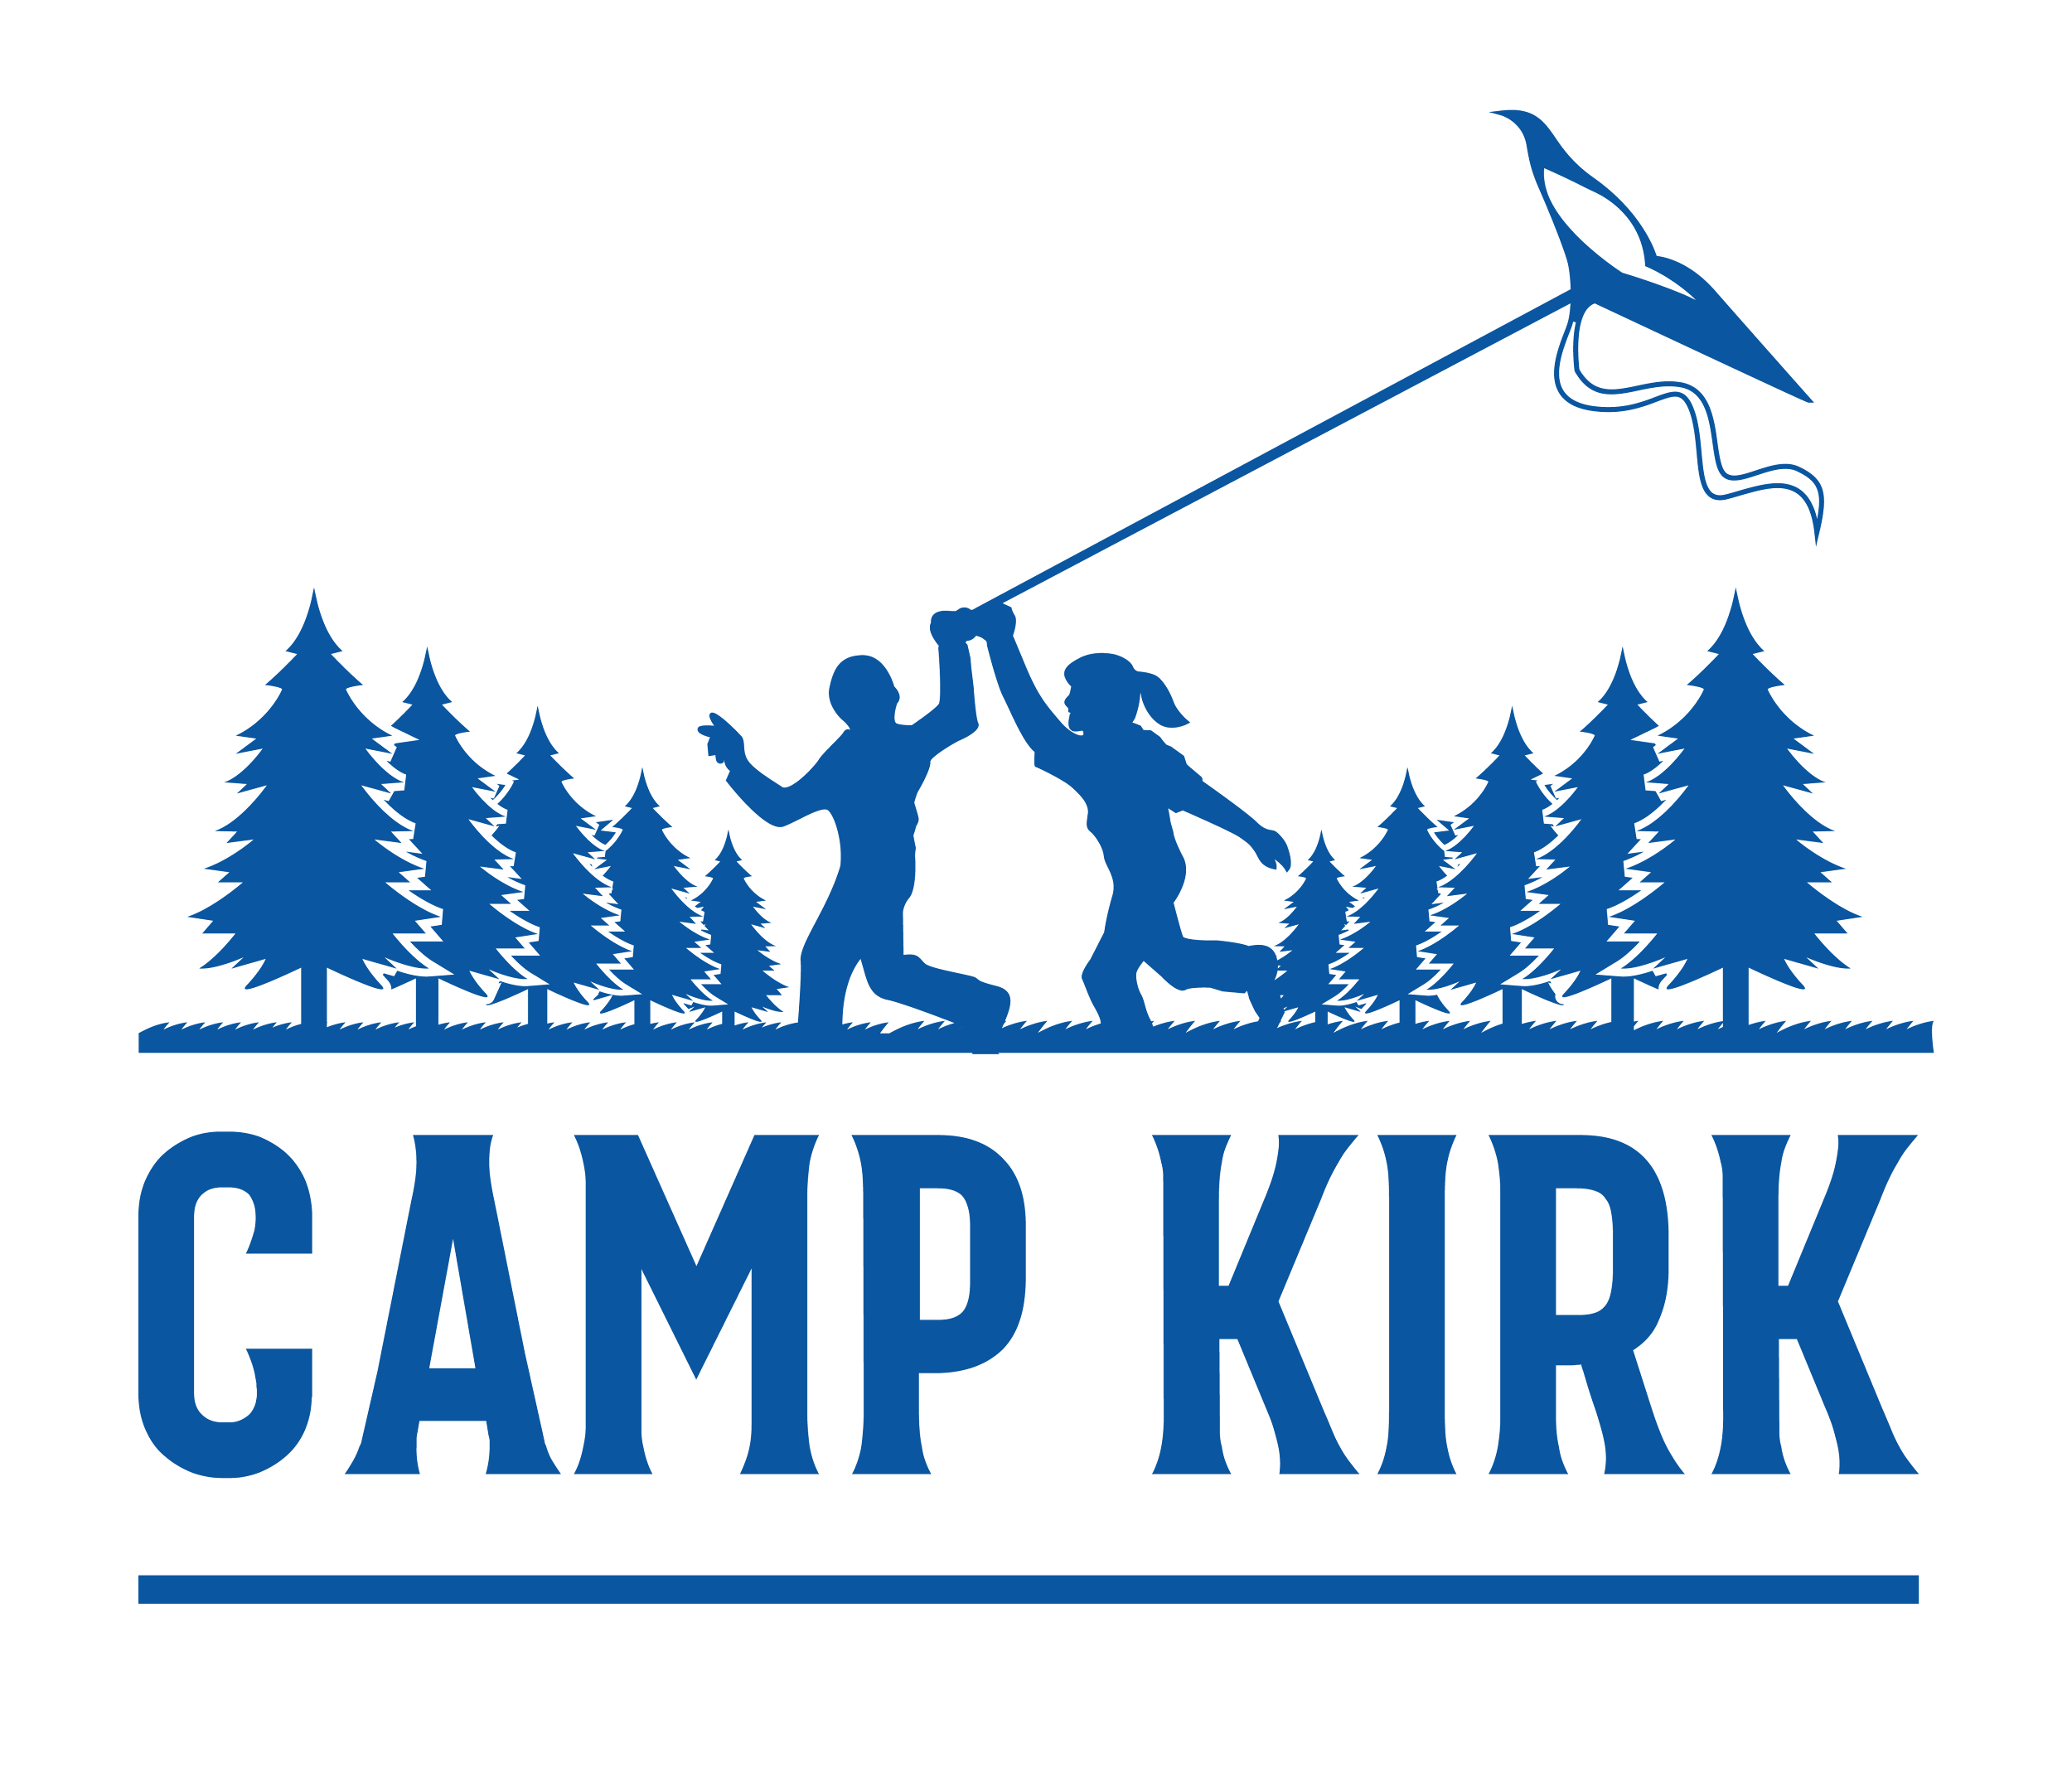

Job Posting:

Kitchen Assistant

ORGANIZATION
Camp Kirk empowers neurodiverse kids and youth to reach their potential through
recreational programs. Within a small and nurturing community, our programs
emphasize strengths so that participants can develop confidence, connection and
community. Camp Kirk supports neurodiverse kids and youth, ages 7-17. The majority of our campers have learning disabilities, autism, and/or ADHD

JOB DESCRIPTION
Kitchen Assistants work alongside the Head Chef and Sous Chef to ensure the smooth operation of Camp Kirk’s catering services. Their duties include:
- Cleaning and sanitizing the kitchen facilities and equipment
- Dishwashing (tableware, pots + pans, cooking equipment)
- Assisting the Chefs in meal preparation
- Assisting in receiving food orders and inventory management
- Garbage disposal, mopping floors

CONTRACT DETAILS + COMPENSATION
The contract runs from June 16 - Aug 27, 2026. Kitchen Assistants reside in cabins with 3-4 other staff members. Compensation for a summer contract is $6,590+ room and board.

REQUIREMENTS
- 19+ years old by June 2026
- Ability to secure Food Handler certification by June 2026
- Willingness to learn on the job and bring a positive attitude to the work environment
- Ability to take instructions when necessary and work as part of a team
- Ability to lift up to 50lbs
- Criminal Record Check or Vulnerable Sector Screening for individuals over 27 years of age

APPLICATION
Please head to campkirk.com/jobs to submit an online application.

Equal Opportunity and Accessibility Commitment
Camp Kirk is an equal opportunity employer and is committed to fostering an inclusive and accessible workplace that celebrates diversity and values the contributions of all individuals. We welcome applicants of all abilities and provide accommodations to ensure equal access throughout the hiring process.
If you require accommodations at any stage of the application or hiring process, please contact us at kristen@campkirk.com or 416 782 3310 and we will work with you to meet your needs.
We strive to ensure our workplace is inclusive and supportive, and we actively promote an environment where all team members can thrive. For more information about our accessibility policies or to request accommodations, visit https://campkirk.com/wp-content/uploads/2021/09/AODA.pdf

